Store Manager

View Adjustment Voucher List

Click “View Adjustment Voucher List” link from menu to view Adjustment Voucher List screen.

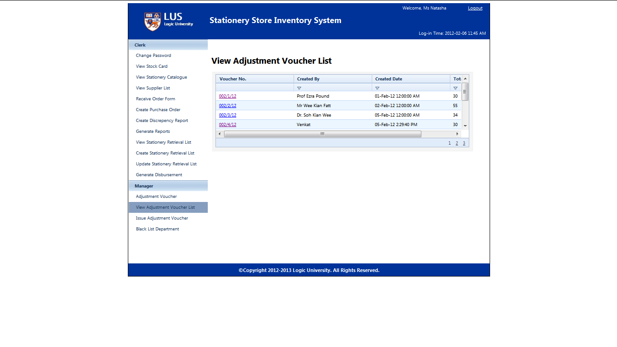

Click voucher number link to view adjustment voucher details screen.

